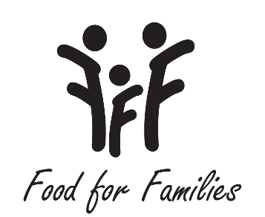

Dear Parents,

**Food for Families** is a non-profit organization that supplies food bags for students in Union County on the weekend. There is no cost to you, and **each** child that goes to a Union County School can receive a bag. The food is given out usually on Fridays at our school and goes in the child’s book bag. If you would like for your child to **RECEIVE** a food bag each week please give permission below. Please return the permission slip by **FRIDAY, September 2nd**to your teacher. Your teacher will give the information to the guidance counselor. Your child will receive a bag the following Friday. This information is confidential. You can talk with your child’s guidance counselor if you have any questions or if you need a food bag anytime during the year. Food for Families’ goal is to have **NO HUNGRY CHILDREN IN UNION COUNTY!**

Yes, I want my child _______________ to receive a food bag on Fridays. He/She is in

________ grade. He/She is in __________________ class.

Please complete this form and return it in a sealed envelope addressed our school counselor, Ms. Cole.