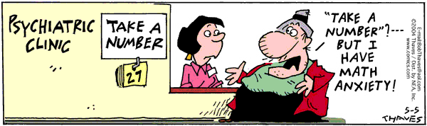

WHAT AM I DOING DURING E-BLOCK?

**MONDAY**: POWER - Silent Reading and Make-Up work day. I need to remember to bring a book. I cannot work on homework, etc. I must be reading for the entire time.

**Location: Homeroom**

**TUESDAY:** Reading tutoring. I have to bring pencil and paper. I need to report directly to my location without going to my locker. I will go to my locker and back to homeroom at 10:50.

Location: ____________________________________________

**WEDNESDAY:** Wild Wednesday,

**My club is _______________________________________________________**

**Location:** ________________________________________________________

Do not go by lockers. I need to report directly to my location ASAP!!! I will be eating with my Wild Wednesday teacher.

**THURSDAY:** Math tutoring. I have to bring pencil and paper. I need to report directly to my location without going to my locker. I will go to my locker and back to homeroom at 10:50.

**Location:** __________________________________________________________

**Friday:** Content Reading - I need to have paper and pencil. I need to report directly to homeroom.

**Location: Homeroom**